ABSTRACT TITLE

Presenting Author1,¹ Author²

¹Affiliation, address
email: hello@xx.yy.pt
² Affiliation, address

The abstract should not exceed one A4 page. Title should be in capital letters, Times New Roman, 14. Authors should be in Times New Roman, 12 and affiliations in Times New Roman, 10. All figures, diagrams and tables must have a caption and be referred in the text. The text must be written in Times New Roman, 12. Use single line spacing, and justified alignment. The content must clearly indicate the objectives, methods used and work conclusions. Bibliographic references must be referred by numbers [1], in the order in which they appear in the text and should be listed at the end of the abstract as illustrated below. The font for references should be in Times New Roman, 11 with single line spacing.

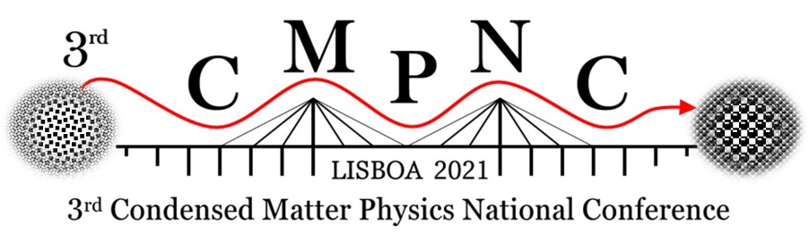

Figure 1/Table 1. For figures resolution 300 dpi or better should be used. The caption for figures or tables must be placed below using Times New Roman, 10 and single line spacing.

Acknowledgements
Work with support from…

References
[1] Author1, Initials, Author2, Initials (year). Title of article. Title of journal, Volume number (Issue number if existing), start and end page (for paper)
[2] Author3, Initials. (year), Title of book (Edition if later than first e.g. n^{rd} ed.). Place of publication: Publisher.

