Title (Times New Roman, boldface, font size 14, centred)
(empty line)
Author^{a.}, Presenting Author^{b}, Author^{c}
(empty line)
ªInstitution or Company a, Full Address
^{b}Institution or Company b, Full Address
^{c}Institution or Company c, Full Address
(empty line)
E-mail address of the corresponding author
(empty line)
(empty line)
Margins: top, bottom, right, left: 2.54 cm
Title: Times New Roman, boldface, font size 14, single line spacing, centred. The title should not exceed 200 characters.
Authors: Times New Roman, regular, font size 11, single line spacing, centred. Given Name Family Name (e.g. Alice Wonderland, Bob A. Doe, Carol B. C. Doe), underline presenting author. Superscripts ª, ^{b}, ^{c}, ... for affiliations.
Affiliations: Times New Roman, regular, font size 9, single line spacing, centred.
E-mail address corresponding author (replace with the e-mail address): Times New Roman, regular, font size 11, single line spacing, left-aligned.
Main text: Times New Roman, regular, font size 11, single line spacing, justified. Reference numbers in square brackets, e.g. [1,3-4]. Please do not use footnotes. Separate paragraphs by a blank line. Figures should be inserted as jpeg or tiff format files.
Figure and table captions: Times New Roman, italic, font size 10, centred and aligned with the figure/table.
References: Times New Roman, regular, font size 9, single line spacing, left-aligned. State author names as: Initials. Family name (see the example below).
(empty line)
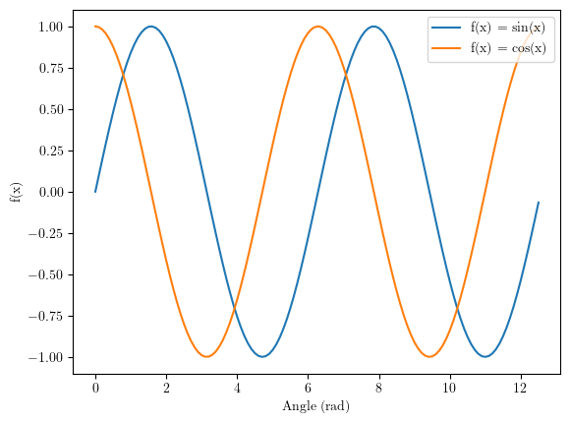
Fig. 1. Example figure.
(empty line)
The abstract should be written in English. It must not exceed one page (figures included).

Please submit your abstract in Word Format (.docx) via the conference website.
(empty line)
(empty line)
References
[1] Authors (M. T. Nguyen-Kim, T. A. Smith), Journal title Year, Volume, Pages.
[2] Authors, Book title, Editors, Publisher, City (Year).

