Title of the contribution
Surname, First. Middle.¹, Surname, First. Middle.², Surname, First. Middle.^{2*}
¹ First affiliation, Address.
² Second affiliation, Address.
*Email: correspondingauthor@email.com

This is the abstract template that authors should follow when preparing their Abstracts to be submitted to the 22nd ICCDU 2025 to be held in Lisbon, Portugal, on June 23-27, 2025.
The language of the abstracts is English. Authors should respect this layout and format, limiting the entire abstract to one A4 page (297×210 mm). All figures (optional and max. size 1 MB) or tables (optional) should be included in the text.
The abstract should state briefly and clearly the objectives, methods, new results and conclusions or significance of the work.
The abstract text should be justified, and the margins of this template should be maintained. The font Times New Roman with 12-point size should be used everywhere except in the title, affiliation and captions for figures or tables.
Authors' first and middle names should be abbreviated. Identify the corresponding author with a superscript asterisk and include his/her e-mail. Identify the presenting author by underlining his/her name. Affiliation should be numbered in the same order as authors.
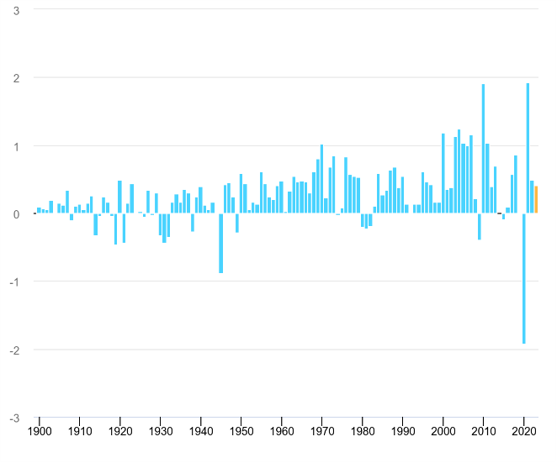
Figure 1. Caption in Times New Roman, 11 pt.

Table 1. Caption in Times New Roman, 11 pt.
Header 1 | Header 2 | Header 3

The references should be indicated as [number].
Abstracts have to be submitted by 17 January 2025 (23:59 GMT +1 h) at the latest.

Keywords: 3 to 4 representative keywords of the work must be included and separated by semicolons.
Acknowledgements: This work was funded by…
References:
[1] Author, A., scientific journal volume (year) pages.
[2] Author, F. M., book title, publishing company, place, year.

