**Title (max. 150 characters)**

A. B. 1st-Author,1 C. D. 2nd-Author,2 E. F. 3rd-Author,3 G. H. Last-Author3

1 *First Affiliation Address, Country*

2 *Second Affiliation Address, Country*

3 *Third Affiliation Address, Country*

Email: 1st-Author@xx.pt

The abstract text must be written in single spaced paragraphs with 9 pt characters using the Times New Roman font available with Microsoft Office.

Please do not add indents to paragraphs. The safest option to avoid formatting errors is to paste the text of your abstract over this one as plain text without any formatting, or copying it from a simple text editor, like Notepad. Do not change line spacing or margins.

If you want to add images or graphics to the abstract, save them as PNG files and insert them as illustrated below in Figure 1.

References should be numbered sequentially in the text using the following superscript style: …benzene,1 or …benzene.1-3 or…benzene,1,2,3-5. They should be compiled in the Reference section using the style illustrated below.

The abstract size is restricted to one page.

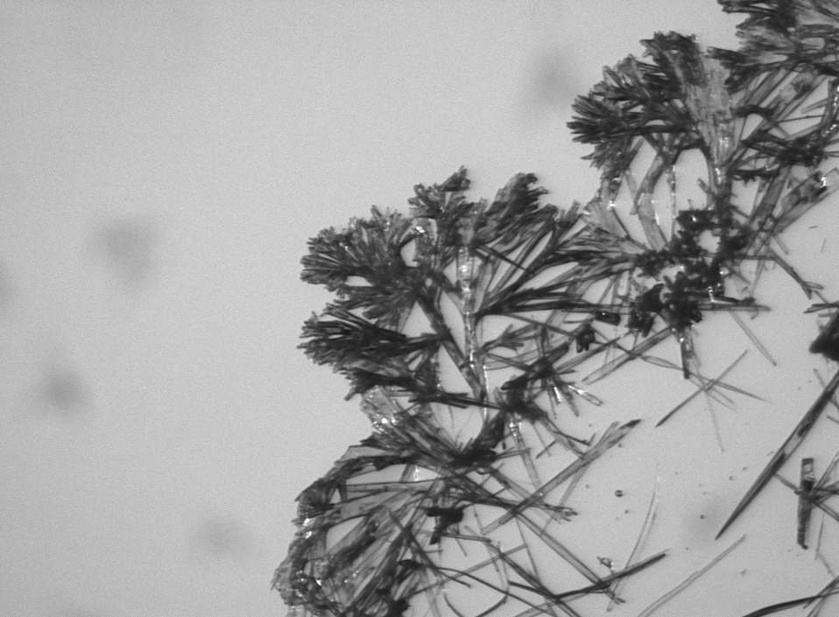

**Figure 1.** Times New Roman 9, aligned center, spacing single.

*Acknowledgements:* The acknowledgements should use the same font, with a size of 8 pt.

**References**

1. A. B. 1st-Author, C.D. Second-Author, E.F. Third-Author, *J. Am. Chem. Soc.* **2014**, *9*, 992-1001.

2. J. J. Li *Triumph of the Heart. The Story of Statins*; Oxford University Press: New York, 2009.